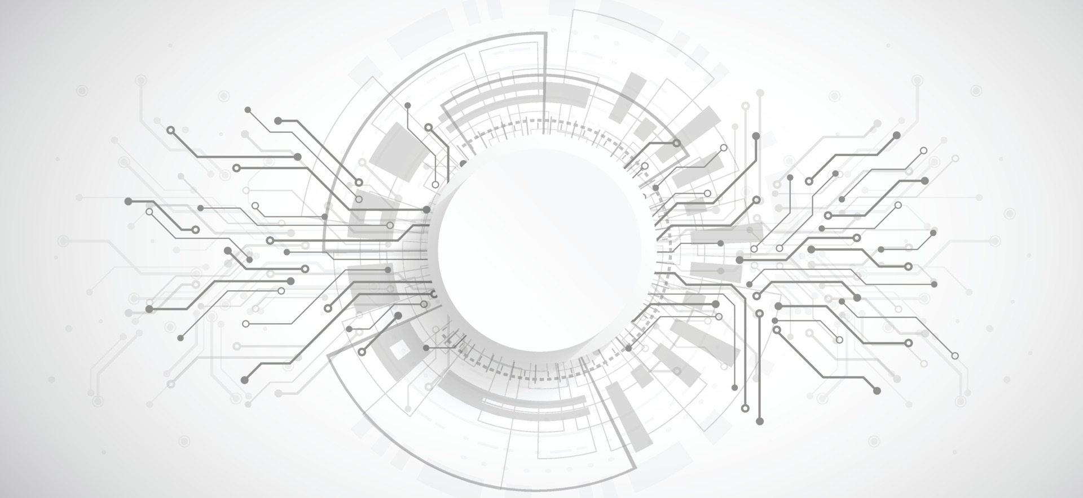



**Make your Drive Digital**

**Components Report**

**Member 1: Member 2:**

**Muhammad Fahad Ahmed Amin**

**(FA19-BSSE-0014) (FA19-BSSE-0063)**

**(Leader)**

**Supervisor:**

**Dr Shaukat Wasi**

**Tuesday, October 18, 2022**

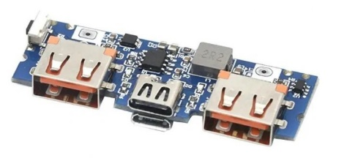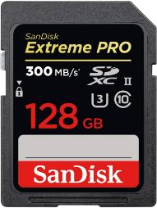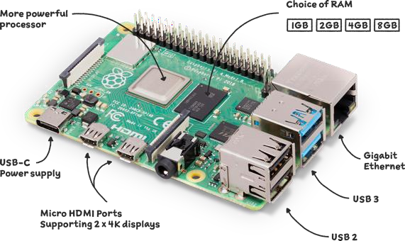

**Raspberry Pi 4 Model B 2019 Quad Core 64 Bit Wi-Fi Bluetooth (4GB)** Dimesnion:3.94 x 2.76 x 1.18 inches

SanDisk 128GB Extreme PRO SDXC UHS-II Memory Card

USB 5V 2.4A Micro/Type- C USB Mobile Power Bank 18650 Charging Module Lithium Battery Charger Board Circuit

Dimension: 55 mm x 18 mm x 9 mm

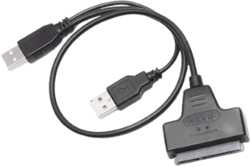 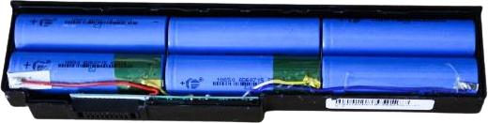 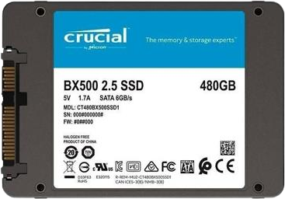

Hard Disk Drive 7+15 Pin SATA to USB 2.0 Adapter Cable for 2.5 Inch HDD Laptop

Dimensions: 6.61 x 5.12 x 0.51 inches

**Power Bank,** **Battery cell**

Per cell:Dimension:49.2mm length and 13.5mm diameter.

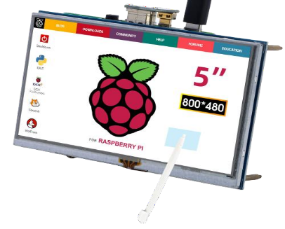

ELECROW 5 Inch Raspberry Pi Screen Touchscreen 800x480 TFT LCD Display HDMI Monitor for Raspberry Pi 4B 3B+ 3B 2B+ BB Black Banana Pi Jetson Nano Windows 10 8 7

Dimension 4.72 x 2.76 x 0.35 inches

**SSD size** Dimension: four inches (101 millimeters) in width, 5.75 inches (146 millimeters) in depth and one to 1.63 inches (25 millimeters to 41 millimeters) in height.

**Raspberry pi 3:**

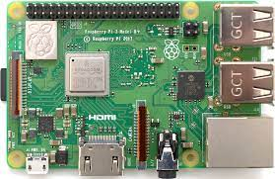

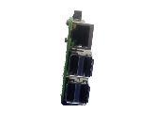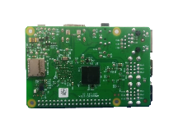

* **Describe the working of Raspberry pi 3?**

The Raspberry Pi 3 is **equipped with a quad-core 64-bit Broadcom BCM2837 ARM Cortex-A53 SoC processor running at 1.2 GHz**, making it about 50% more powerful than the Pi 2. Which means the new Raspberry Pi 3 can be used for office applications and web browsing.

* **Why you use it in the FYP project and also write down it’s priority (**High /Medium / Low**)?**

The Raspberry Pi 3 is used in this project because it’s a mini computer, so that we can preview data as well as share it to other connected devices. Its priority is very **High** becausewithout it the other wholematerials are useless.

* **Any Other alternate which can used in this project?**

1. Raspberry pi 4
2. Raspberry Pi 2
3. Raspberry Pi 3+

* **Other:**

|  |  |
| --- | --- |
| Clock frequency: | 1200 MHz |
| Processor: | 64-bit quad-core ARM Cortex-A53 |
| RAM: | 1024 MB |
| Wi-Fi: | Yes |
| Bluetooth: | Yes, 4.1 |
| Power supply: | 5v 2.5A |
| Storage: | MicroSD card |
| Network adapter: | Ethernet network card |
| USB ports: | 4 |
| 2.5A USB: | Yes |

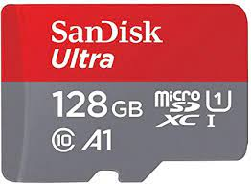**SanDisk 128GB:**

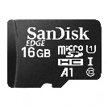

* **Describe the working of SanDisk 128GB?**

Data in an SD card is stored on a series of electronic components called NAND chips. These chips allow data to be written and stored on the SD card. As the chips have no moving parts, data can be transferred from the cards quickly, far exceeding the speeds available to CD or hard-drive media.

* **Why you use it in the FYP project and also write down it’s priority (**High /Medium / Low**)?**

We use 128 GB memory because it helps in fast processing as well as there should be spaces so that we can easily store other data. Its priority is very **High** because Operation system will in it.

* **Any Other alternate which can used in this project?**

1. 64 GB Memory Card
2. 32 GB Memory Card
3. 8 GB Memory Card and other

**Type C USB 5V 1-2.4 A:**

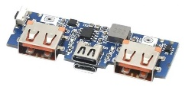

* **Describe the working of SanDisk 128GB?**

Power banks work by **using sophisticated electronics to manage taking in charge from a charger, storing it in a battery and then charging other devices**. Power banks are not just a simple battery: they use sophisticated electronics circuitry to manage being charged, and then charging other devices.

* **Why you use it in the FYP project and also write down it’s priority (**High /Medium / Low**)?**

We use to provide constant amount of output from the power bank because we need to get 5 volts for raspberry pi and 5 volts for the hard drive, so it’s priority is very **High**.

* **Any Other alternate which can used in this project?**

1. LED Dual USB 5V 2.4A Micro/Type-C USB Mobile Power Bank 18650 Charging Module Lithium Battery Charger Board Circuit
2. Dual USB QC or 5V 2.4A MicroUSB / Type-C / Lightning USB Mobile Power Bank 18650 Charging Module Lithium Battery

**Hard Disk Drive 7+15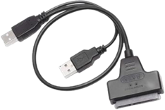:**

* **What is the HDD connector called?**

The most common hard disk drive interface for end-users is called ATA (Advanced Technology Attachment), while SATA (Serial ATA) interface was created to replace ATA and is becoming more popular these days. After the release of SATA, ATA interface started being also called PATA (Parallel ATA).

* **Are all HDD cables the same?**

**Yes, they are**. While the SATA ports may correspond to different version and while the choice of SATA port matters when installing a hard drive, the cables are all the same.

* **Why you use it in the FYP project and also write down it’s priority** (High /Medium / Low)**?**

We use it to transfer information from hard drive to raspberry pi, so that the user can preview the data and get information.

 **Power Bank, Battery cell:**

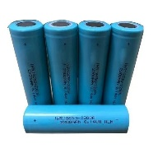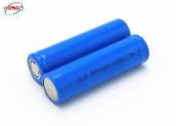

* **Which cells are used in power bank?**

All power banks feature mainly two types of batteries: **Lithium Ion (Li-ion) and Lithium Polymer (LiPo)**. Li-ion batteries come in a cylindrical-shaped plastic case. These batteries require low maintenance and are cheaper than LiPo batteries but have a higher energy density.

* **How does a power bank works?**

How Does a Power Bank Work? A power bank's built-in battery charges through an external power supply, such as a wall socket, then stores the energy in chemical form. When needed, the battery sends electrical energy to the connected device via the output port.

* **Are power banks AC or DC?**

The PowerBank™ is a battery powered AC generator and Uninterruptible Power Supply (UPS) that stores electricity for use when and where power from the grid is unavailable: remote, off-grid, emergency and black-out scenarios.

 **ELECROW 5 Inch Raspberry Pi:**

* **Describe the working of ELECROW 5 Inch Raspberry Pi?**

Raspberry Pi OS provides touchscreen drivers with support for ten-finger touch and an on-screen keyboard, giving you full functionality without the need to connect a keyboard or mouse. The 800 x 480 display connects to Raspberry Pi via an adapter board that handles power and signal conversion.

* **Why you use it in the FYP project and also write down it’s priority (**High /Medium / Low**)?**

Its priority is very **High** because without seen anything you can’t do anything, so the part is very important from the start of install till you working.